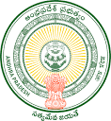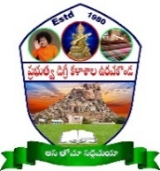**GOVERNMENT DEGREE COLLEGE**

**URAVAKONDA - 515 812**

(Accredited by NAAC with B Grade)

Affiliated to S K. University, Ananthapuramu

**PERSONAL PROFILE**

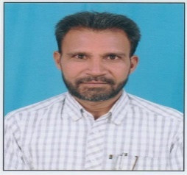

**T.N. MASTHANAPPA**

**Lecturer in English,**

Photo

**Govt.Degree College, Uravakonda**

**email: mayaeng5@gmail.com**

**Educational Qualifications:**

M.A.(ENG)., SLET, (Ph.D.)

**Professional Experience:**

12 years as DL in English (24-12-2011 to till to date)

* Govt. Degree College, Tadipatri (From 24-12-2011 to 26-05-2017)
* SKP Govt Degree College. Guntakal (From 27-05-2017 to 01-08-2023)
* Govt Degree College, Uravakonda (From 02-08-2023 to till to date)

**Academic Development: (RC, OC, FDP, TOT, MOOCS, Training programmes etc.)**

1.Attended Six-Day (Residential) INDUCTION PROGRAMME (Six-Day Training Programme for Newly Recruited Lecturers) at KVR Government Degree College for Women, Kurnool from 26-12-2011 to 31-12-2011.

2.Attended 21 Day- Refresher Course Programme from 04-07-2013 to 24-07-2013 at UGC-ASC, Hyderabad Central University, Hyderabad.

3.Attended One Month Orientation Course Programme from 10-12-2013 to 08-01-2014 at UGC-ASC, Osmania University, Hyderabad.

4. Attended Seven-Day (Residential) ELF (English Language Fellow) Programme on ‘SKILLS UPDATE WORKSHOP’ at ASCRC, Osmania University, Hyderabad from 22-02-2012 to 28-02-2012.

5. Attended Six-Day (Residential) ELF-RTP (ENGLISH LANGUAGE FELLOW- ENGLISH LECTURERS RETRAINING PROGRAMME) at Government Degree College for Men at Anantapur from 10-09-2012 to 15-09-2012.

6. Attended Six-Day (Residential) ELF-RTP (English Language Fellow Re-Training Programme) on ‘ENGLISH LECTURERS RETRAINING WORKSHOP’ at MRC, HRD, Hyderabad from 25-02-2013 to 02-03-2013.

7. Attended Four-Day (Residential) TISS (Tata Institute of Social Sciences) Training at SRR & SKR College, Vijayawada from 10.12.2014 to 13.12.2014.

8. Attended One Week International Online faculty development programme (FDP) on “Multidisciplinary in Research Methodology” from 11.09.2023 to 17.09.2023 organised by Y.N.C. College, Narasapur, West Godavari District.

9. Attended Training in English Teaching for Government Degree College Faculty, A.P., conducted by centre for consultancy and language training (CCLT), EFL university, Hyderabad from 04.12.2023 to 08.12.2023.

**Administrative Responsibilities:**

* Co-ordinator for UG Examinations and Dr. BRAOU
* NAAC - Member
* IQAC - Member
* Language Association - Member
* Press – Public Relationship Committee – Convenor
* Purchasing Committee – Member
* RUSA – Member
* Inclusive Canters – Member
* College Website - Convenor
* College Magazine Editorial Board - Member

**Achievements:**

**Appointed as an Assembly Level Master Trainer (ALMT) and Nodal Officer for General Elections-2024 by DEO & District Collector, Anantapuramu and Returning Officer and Joint Collector, Uravakonda.**

**Research Publications:**

Nil